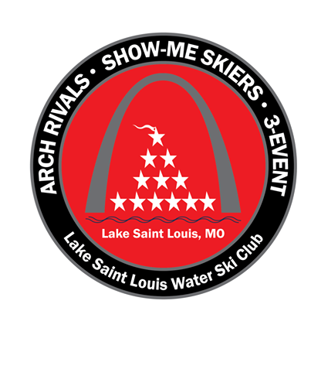

Business/Name: Contact Person:

Address:

Phone: Email:

|  |  |  |
| --- | --- | --- |
| Sponsorship Level | Benefits | Specifications |
| **Circle One**:  Business Card Ad 125 3 ½ x 2  ¼ Page Ad 250 7 ½ x 2 ½  ½ Page Ad 500 7 ½ x 4 ½  Full Page Ad 1000 8 x 10  Corporate Sponsor 2500 8 x 10  Premier Sponsor 5000 8 x 10  Good Luck Ad 40 2 ½ x 2 ½  (text only) | *All* sponsors will be listed on lslski.com website.  Sponsors donating 500, 1000, 2500 and 5000:  *Business logo on the main show boat  *Business logo on our social media pages  (Facebook, Twitter, and Instagram) *Announced at tournaments and Friday  Night Shows  *Listed on [www.lslski.com](http://www.lslski.com) website  with a link to business website | JPEG format (preferred) or High Res PDF  Photos need to be minimum 300ppi  Photos with less than 300ppi will not print well and quality cannot be guaranteed.  Approximately 2000 brochures will be printed with 40 – 44 pages each  Good Luck Ads are typically words of encouragement from friends/family |
| Donation Amount: |  |  |

*Good Luck Ad (text): _________________________________________________________________________________________

(1) Circle ad type

(2) Send .jpeg copy of advertisement to: [gramolino@aol.com](mailto:gramolino@aol.com)

(3) Submit a copy of this page and check payable to: Lake Saint Louis Water Ski Club (LSLWSC)

6311 Reagan Blvd #175

Lake St. Louis MO 63367

(4) You will be provided with donation letter.

Since we are a 501(c)3 organization, we rely solely on countless hours of volunteerism from our members as well as generous donations from individuals and businesses such as yourself! Thank you for supporting an organization that makes a difference in so many lives!

Laura Gramolino

Vice President,

Lake St. Louis Water Ski Club

314/602.7007

gramolino@aol.com